Half Pipe Coil: Quantity: Coded Marking:
Spec. No.: | Grade: |  | Heat#: | 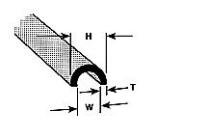
Description:
Stamping: |  | MTR Received: Yes No
List Inspection Points:
H: W: T: Radius:
Other:

Accepted: |  | Rejected:
Job #: PO# Date: M&TE Serial # No serial number

Dipple Jacket: Quantity: Coded Marking:
Spec. No.: | Grade: |  | Heat: | 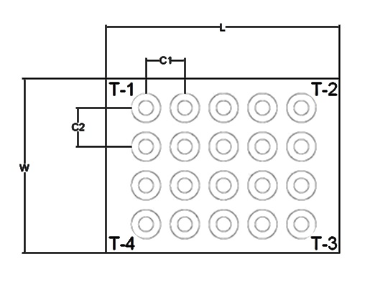
Description:
Stamping: |  | MTR Received: Yes: No
List Inspection Points: L: T1: T3: C1:
W: T2: T4: C2:
Other:

Accepted: |  | Rejected:

Material Accepted: _______________ Date: _____________________
Line:

